Spring Data JPA - Quick Example

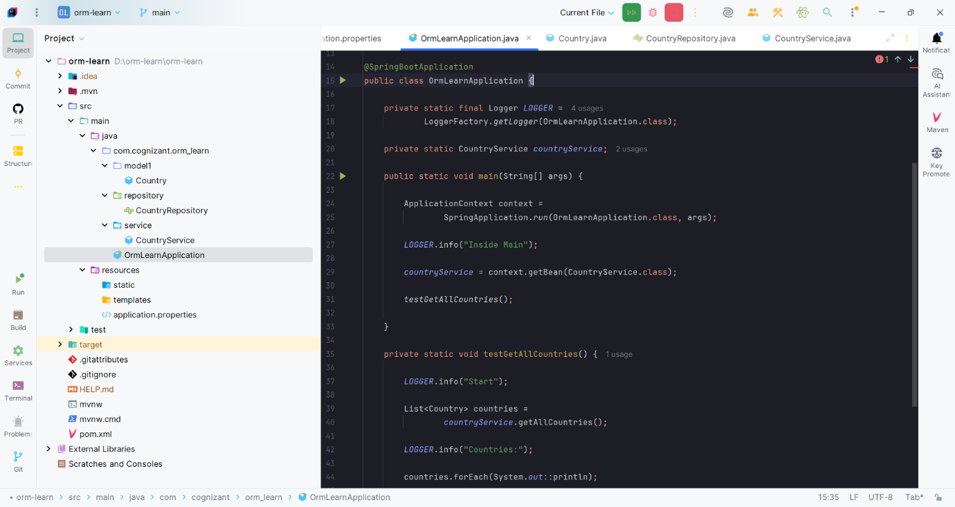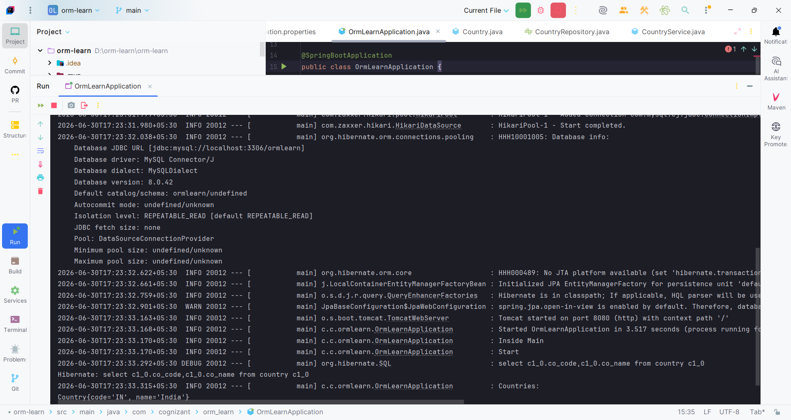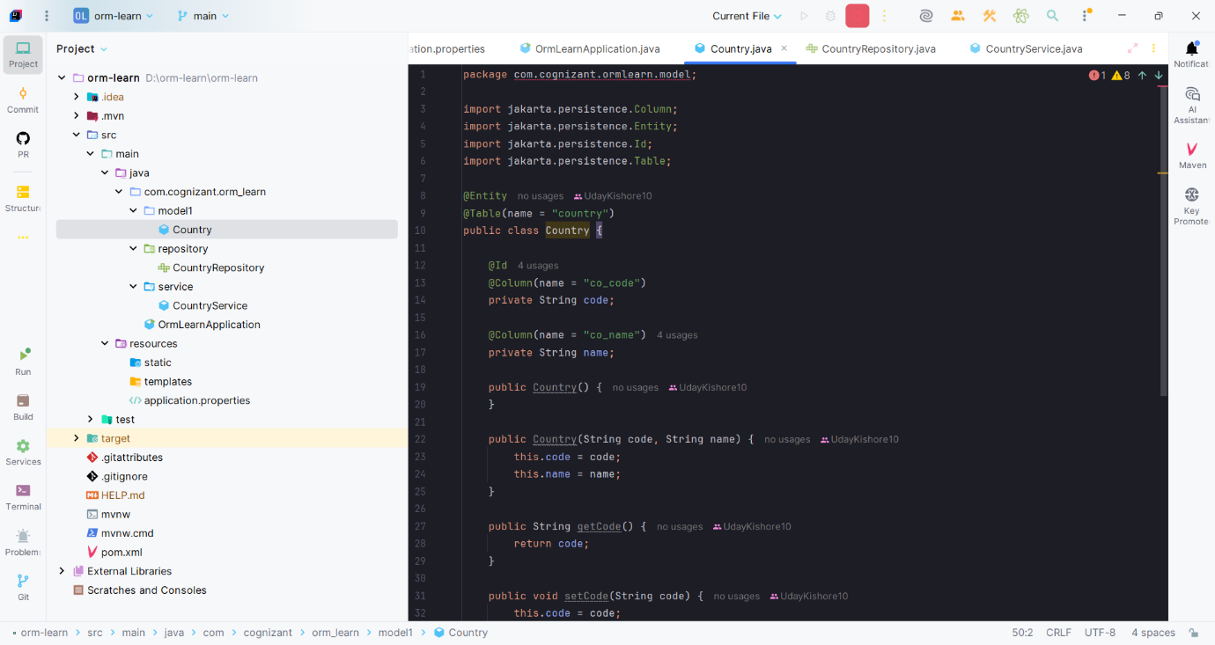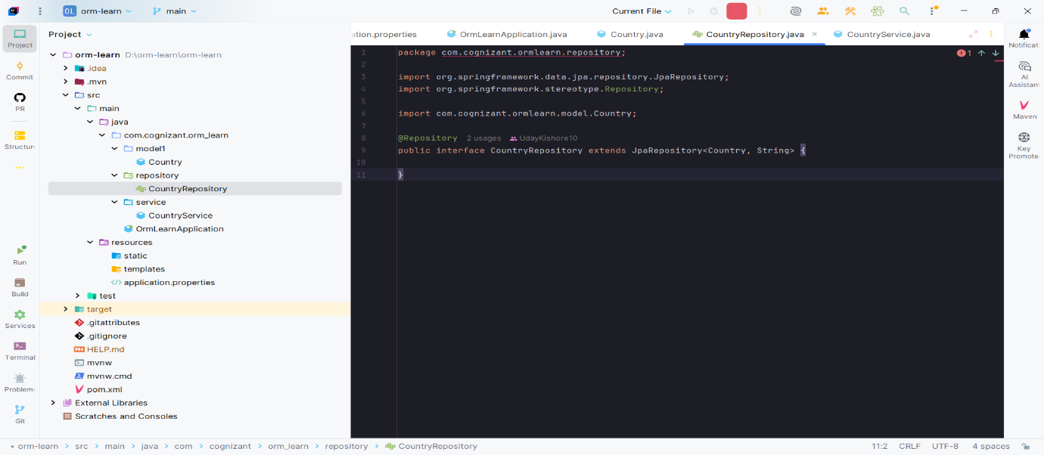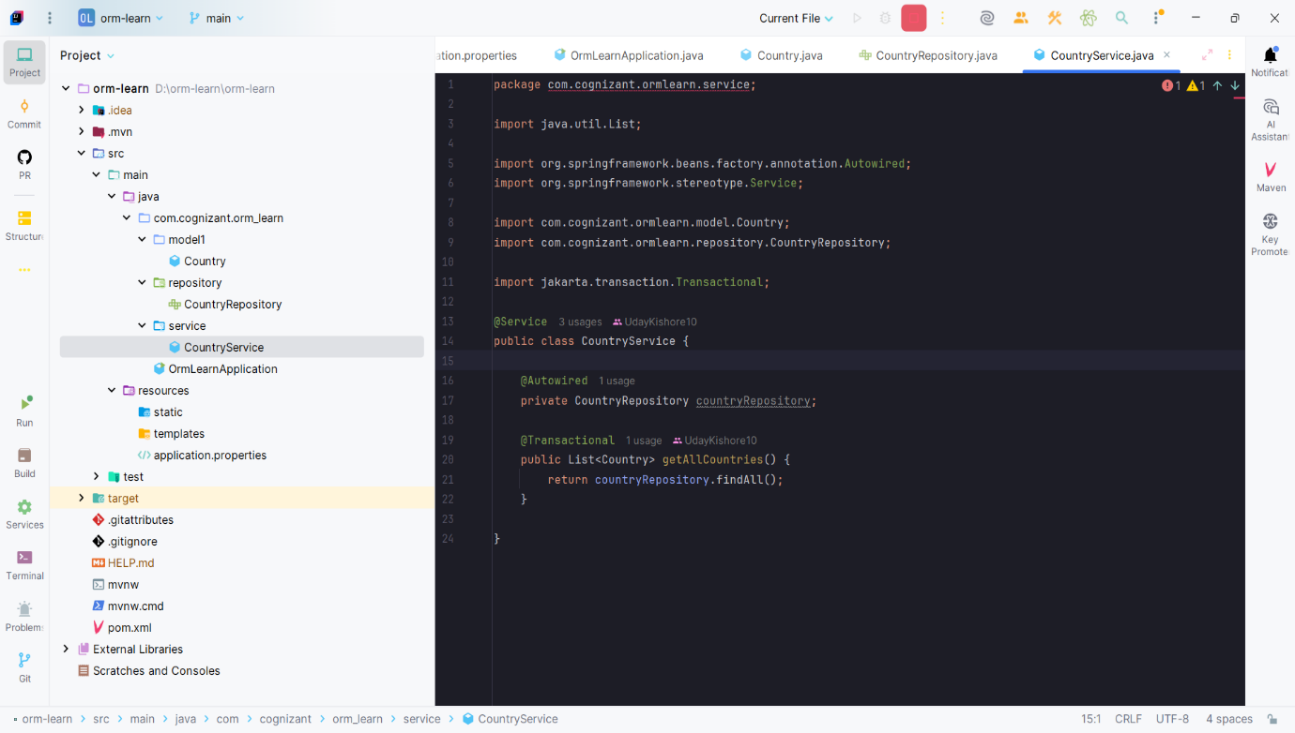

Difference Between JPA, Hibernate, and Spring Data JPA
1. JPA (Java Persistence API)
- Type: Specification (standard)
- Purpose: Defines how Java objects map to database tables.
- Cannot access the database directly.
- Needs an implementation like Hibernate.
Example annotations:
- @Entity
- @Table
- @Id
- @Column

2. Hibernate
- Type: ORM Framework
- Purpose: Implements JPA and performs database operations.
- Automatically converts Java objects into SQL queries.
- Manages sessions, transactions, and CRUD operations.
Example:
session.save(employee);

3. Spring Data JPA
- Type: Spring Framework module
- Purpose: Built on top of JPA (usually using Hibernate).
- Reduces boilerplate code.
- Provides built-in CRUD methods through JpaRepository.
- Handles transactions automatically using @Transactional.
Example:
employeeRepository.save(employee);

Simple Flow
Java Class
│
Spring Data JPA
│
Hibernate
│
MySQL
Why Spring Data JPA?
Hibernate
Open Session
↓
Begin Transaction
↓
Save
↓
Commit
↓
Close Session
Spring Data JPA
employeeRepository.save(employee);
Spring automatically manages the session and transaction, making the code much shorter and easier to maintain.

